**Course Number: AIT 524 DL1**

**Shane Armstrong**

**Week 10 Homework Assignment 9 Joins**

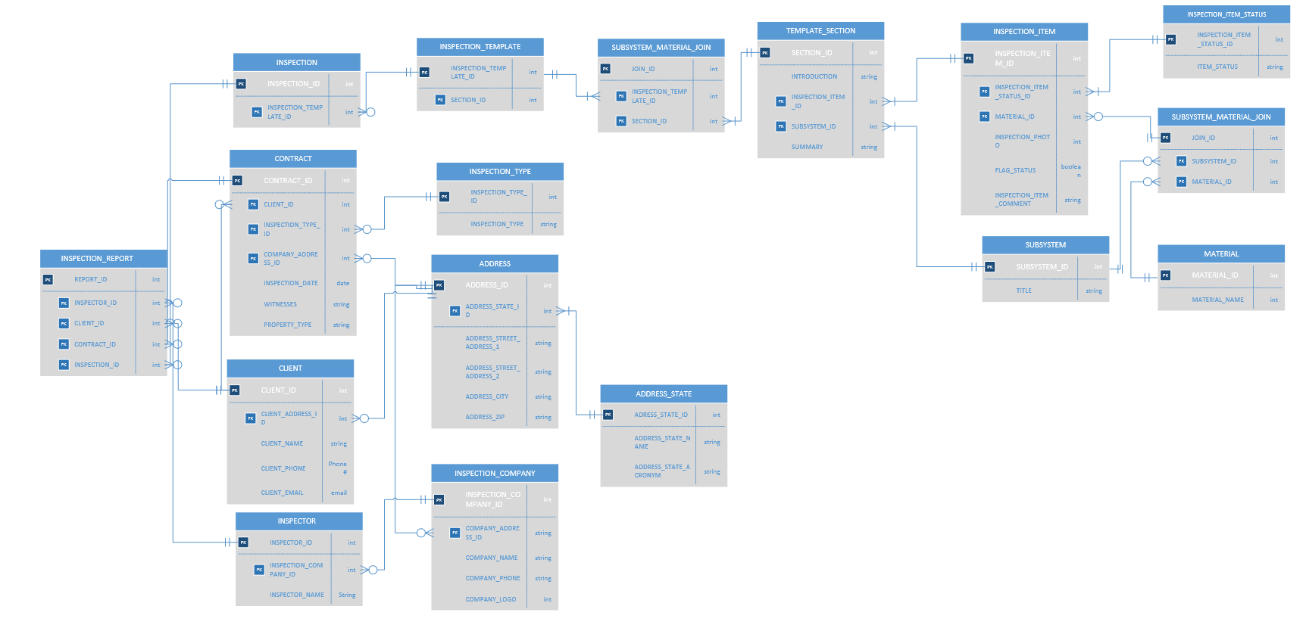

1 Retrieve all client names, emails, and inspection dates of inspections since 2014

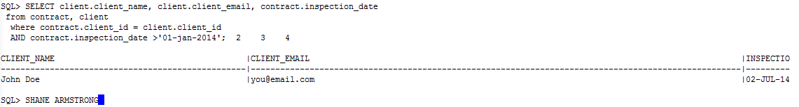

2. Repeat problem 1 using the JOIN … USING keywords.

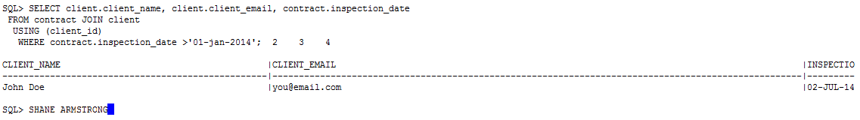

3. Repeat problem 1 using the JOIN … ON keywords.

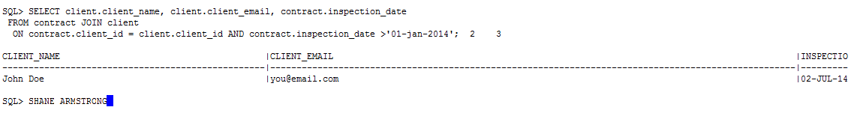

4. Repeat problem 1 but add at least two conditions in the WHERE statement and use an arithmetic and a special operator. Use logical operators to combine multiple conditions. Explain what the query is intended to do.

Retrieve all client names, emails, witnesses and inspection dates of inspections witnessed by 'the inspector' and happened since 2014

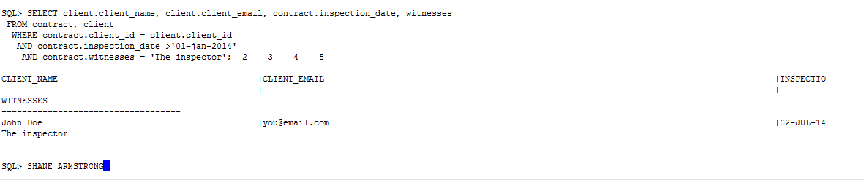

5. Repeat problem 2 but add two more conditions in the WHERE statement and use an arithmetic and a special operator which are different from the ones you used in the previous query. Use logical operators to combine multiple conditions. Explain what the query is intended to do. JOIN…USING

Retrieve all client names, emails, witnesses and inspection dates of inspections performed for client Shane Strong before 2014

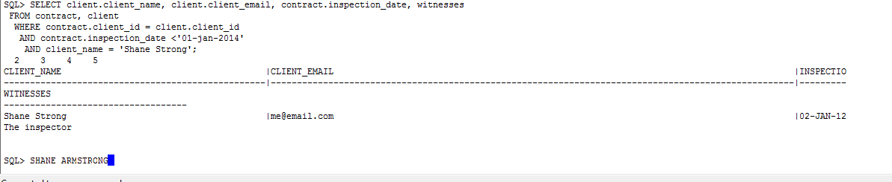

/* 6 - 9. Repeat problems 1-4 above to join three tables. */

6. Repeat problem 1 using the JOIN … USING keywords with three tables

Retrieve all client names, emails, inspection dates, and zips of inspections since 2014

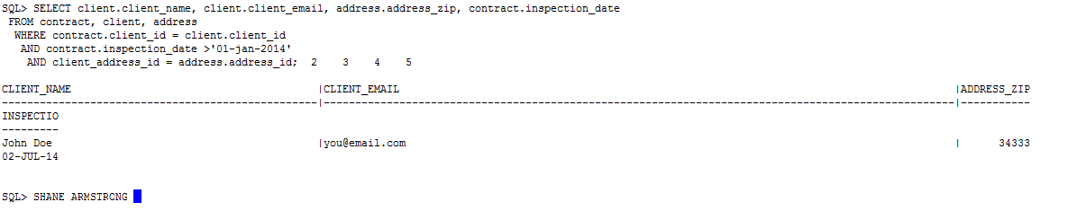

7. Repeat problem 1 using the JOIN … USING keywords with three tables

Retrieve all client names, emails, inspection dates, and zips of inspections since 2014

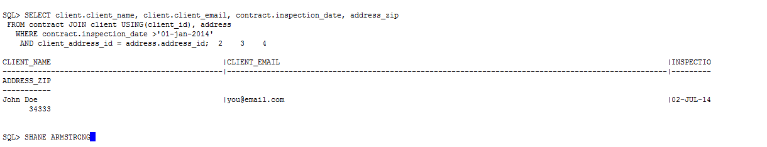

8 Repeat problem 1 using the JOIN … ON keywords with three tables

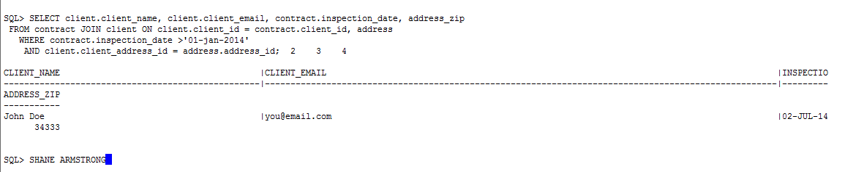

9. Repeat problem 1 but use three tables and add at least two conditions in the WHERE statement and use an arithmetic and a special operator. Use logical operators to combine multiple conditions. Explain what the query is intended to do.

Retrieve all client names, emails, witnesses and inspection dates of inspections witnessed by 'the inspector', clients with a zip of 34333, and happened since 2014

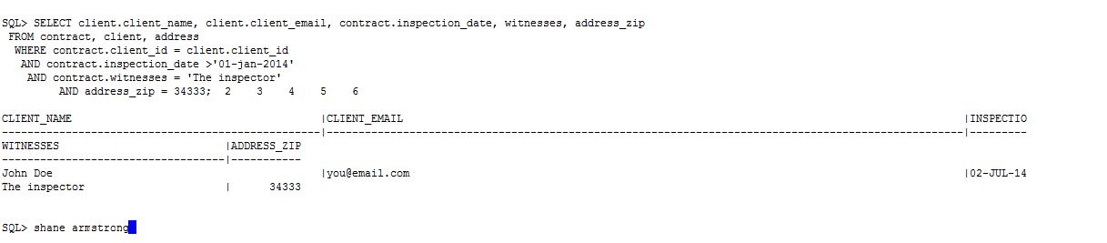

10. Write a SQL query that joins four tables using any type of join and uses both an arithmetic and special operator. Explain what the query is intended to do.

